**DAYANAND ACADEMY OF MANAGEMENT STUDIES**



**BACHELOR OF COMPUTER APPLICATION (B.C.A)**

**BATCH (2022 – 2025)**

**Project 1**

**Serverless Image Processing**

**Submitted to:-** **Submitted by:-**

**Mr. Abhinav Dwivedi Taran Deep Singh**

**Trainer B.C.A 4-(B)**

**Serverless Image Processing**

To create a serverless image processing application that automatically resizes and optimizes images uploaded to an Amazon S3 bucket, you can use AWS Lambda, Amazon S3, and Amazon CloudFront. Here's a high-level overview of the steps:

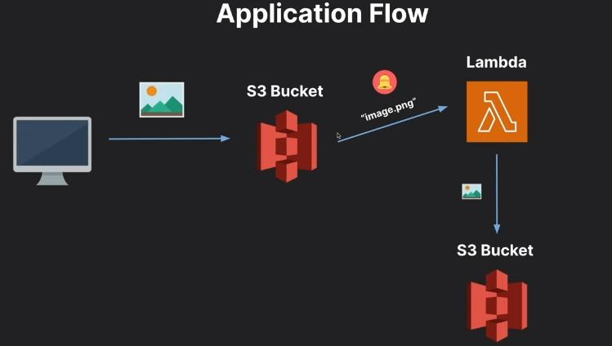

## Step 1 – Creating S3 buckets

### We will use two S3 buckets:

1. source Bucket: For storing uploaded images.

2. destination Bucket: For storing processed images.

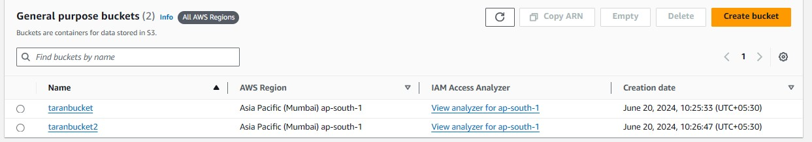

**Step 2 – Configuring S3 bucket policy**

**In ‘Block Public Access settings for this bucket’ section disable “block all public access”.**

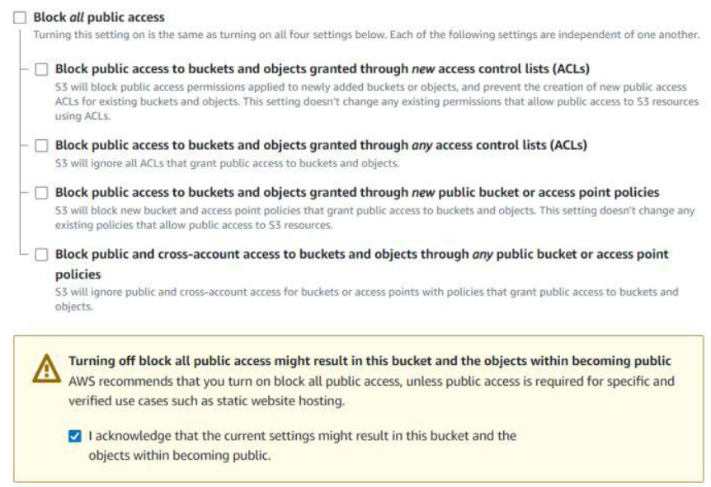

**Step 3 – Creating police in Iam**

**Go to AWS I am console. Navigate to policies section. Click Create policies in (JSON) and name it “taranpolicy ”. Leave all other settings as default. Create the policy.**

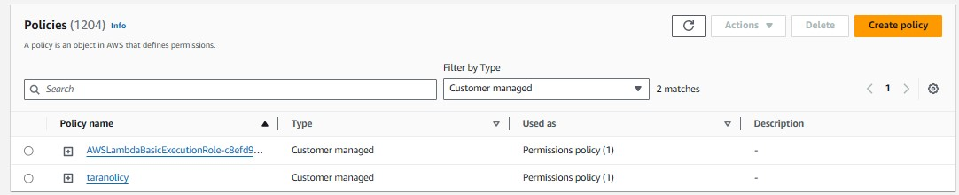

**Policy:**

{

"Version": "2012-10-17",

"Statement": [

{

"Effect": "Allow",

"Action": [

"logs:PutLogEvents",

"logs:CreateLogGroup",

"logs:CreateLogStream"

],

"Resource": "arn:aws:logs:*:*:*"

},

{

"Effect": "Allow",

"Action": ["s3:GetObject"],

"Resource": "arn:aws:s3:::BUCKET_NAME/*"

},

{

"Effect": "Allow",

"Action": ["s3:PutObject"],

"Resource": "arn:aws:s3:::DEST_BUCKET/*"

}

]

}

**\*BUCKET_NAME = SOURSE BUCKET NAME(“taranbucket”)**

**\*DEST_BUCKET = DESTINATION BUCKET NAME(“taranbucket2”)**

**Step 4 –creating role in I am**

**Following Steps are Follows**

*Go to aws I am console

*Create role

*name taranrole

*Use case – Lambda

*Select--taranpolicy

*Then create role

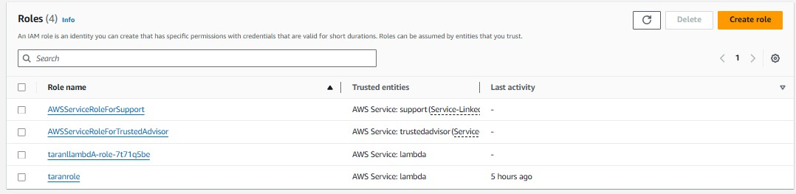

**Step 3 – Creating Lambda function**

Go to AWS Lambda console. Navigate to Functions section. Click Create Function and name it “ImageProcessing”. Select runtime as “NodeJS 18.x” and architecture as “x86_64”. Leave all other settings as default. Create the function.

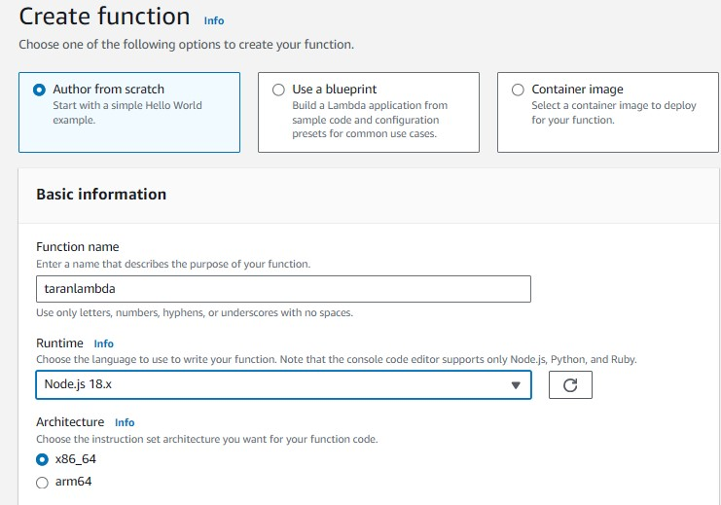

**\*Change default execution role**

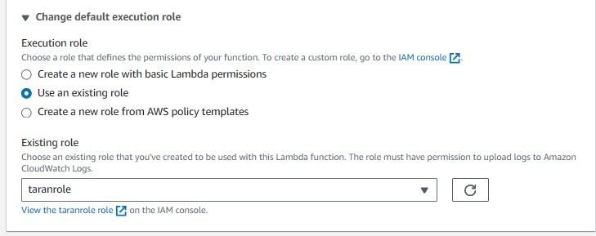

**\*Create function**

**Step 6 -upload zip file in Lambda function**

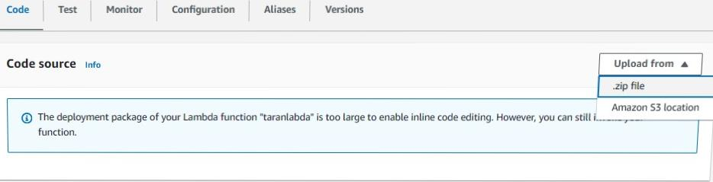

*Zip file link-https://github.com/OneLightWebDev/image-resizer-lambda

**Step 7** - Edit environment variables

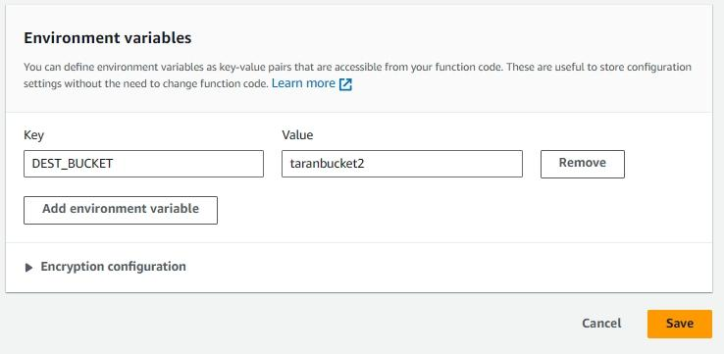

**Step 8 – Test Lambda Function**

*Go to AWS Lambda console. Navigate to Functions section.

*open function then will be created

*open test console

*template=s3-put

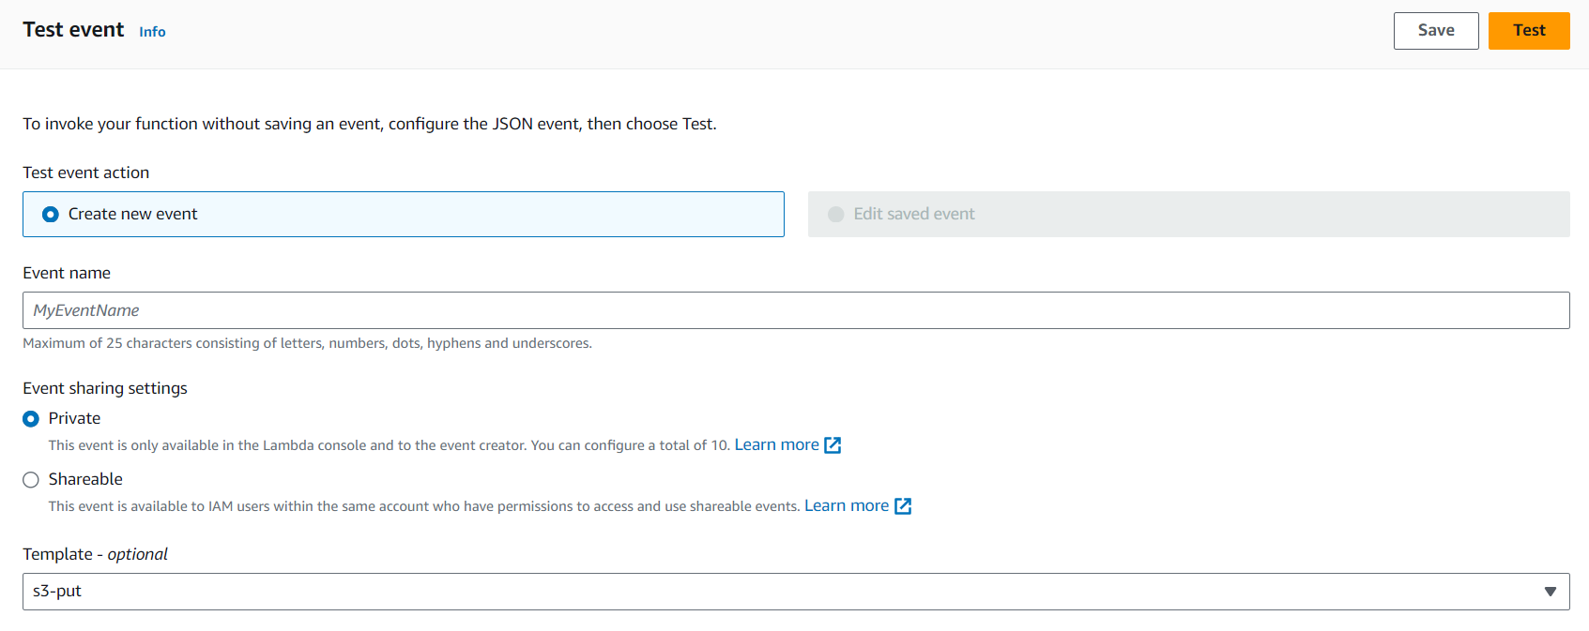**EVENT JSON**

In event json we can change only 3 value

*name, arn, key

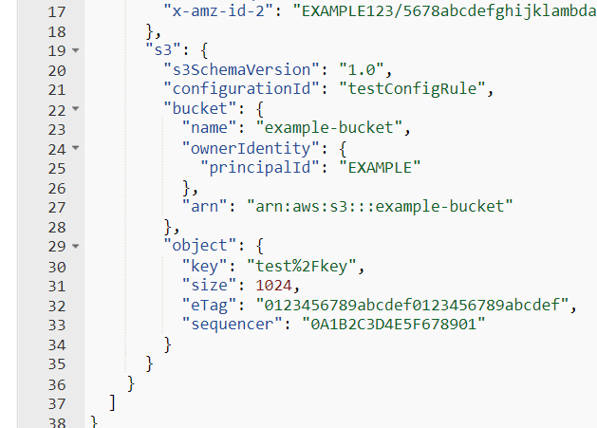

"name":"taranbucket",->

"arn": "arn:aws:s3::: taranbucket "->

"key": "download. jpeg",->



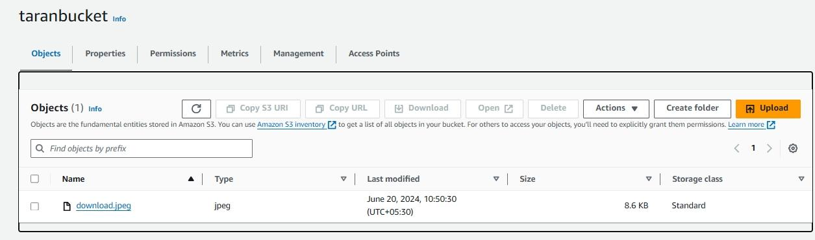

**Now we can test**

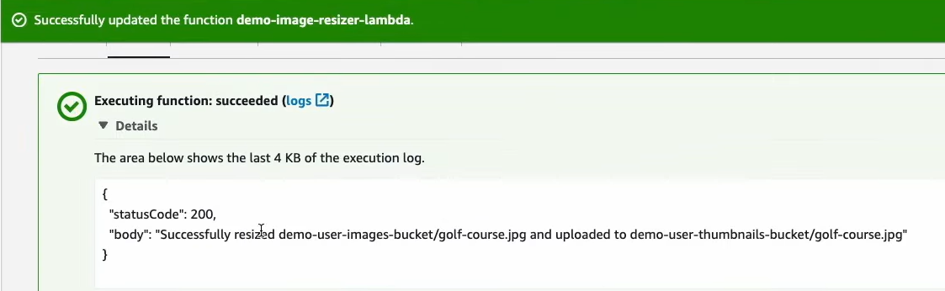

**Step 5 – Creating S3 trigger**

*Add trigger

*Select s3

*choose source Bucket name

*Now Add

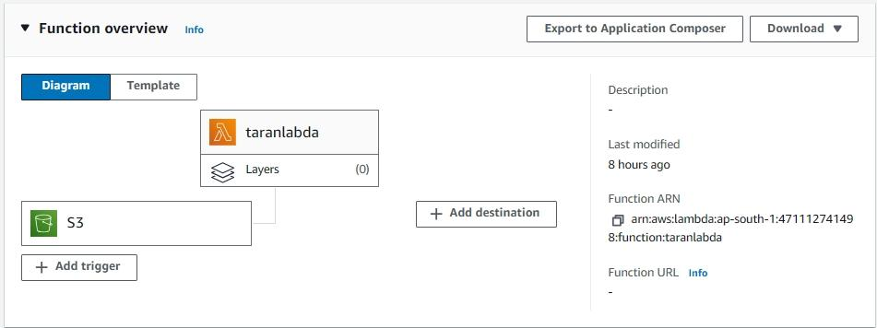

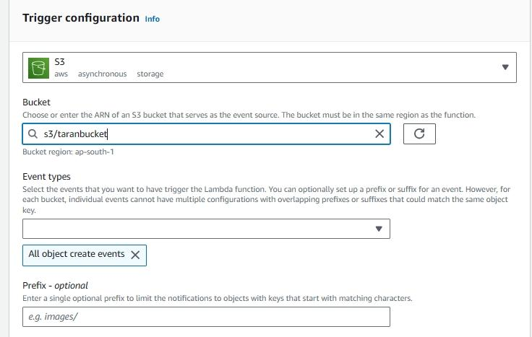

**Upload image in source Bucket**



**Original image**



**Destination Bucket**

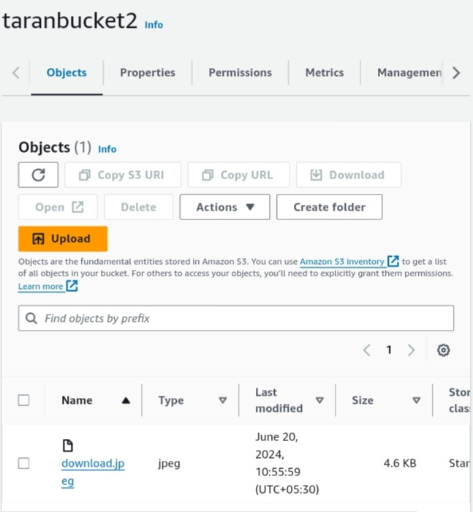

**Resize Image**

